<https://unsupervisedmethods.com/cheat-sheet-of-machine-learning-and-python-and-math-cheat-sheets-a4afe4e791b6>

**Cheat Sheet of Machine Learning and Python (and Math) Cheat Sheets**

*If you like this article, check out another by Robbie:*[*My Curated List of AI and Machine Learning Resources*](https://unsupervisedmethods.com/my-curated-list-of-ai-and-machine-learning-resources-from-around-the-web-9a97823b8524)



There are many facets to Machine Learning. As I started brushing up on the subject, I came across various “cheat sheets” that compactly listed all the key points I needed to know for a given topic. Eventually, I compiled over 20 Machine Learning-related cheat sheets. Some I reference frequently and thought others may benefit from them too. This post contains 27 of the better cheat sheets I’ve found on the web. Let me know if I’m missing any you like.

Given how rapidly the Machine Learning space is evolving, I imagine these will go out of date quickly, but at least as of June 1, 2017, they are pretty current.

If you want all of the cheat sheets without having to download them individually like I did, [I created a zip file containing all 27](https://www.dropbox.com/s/v3yg8djhdf24g6v/UnsupervisedMethods.com%20-%20Cheat%20Sheets.zip?dl=0). Enjoy!

If you like this post, give it a ❤️ below.

**Machine Learning**

There are a handful of helpful flowcharts and tables of Machine Learning algorithms. I’ve included only the most comprehensive ones I’ve found.

**Neural Network Architectures**

Source: <http://www.asimovinstitute.org/neural-network-zoo/>

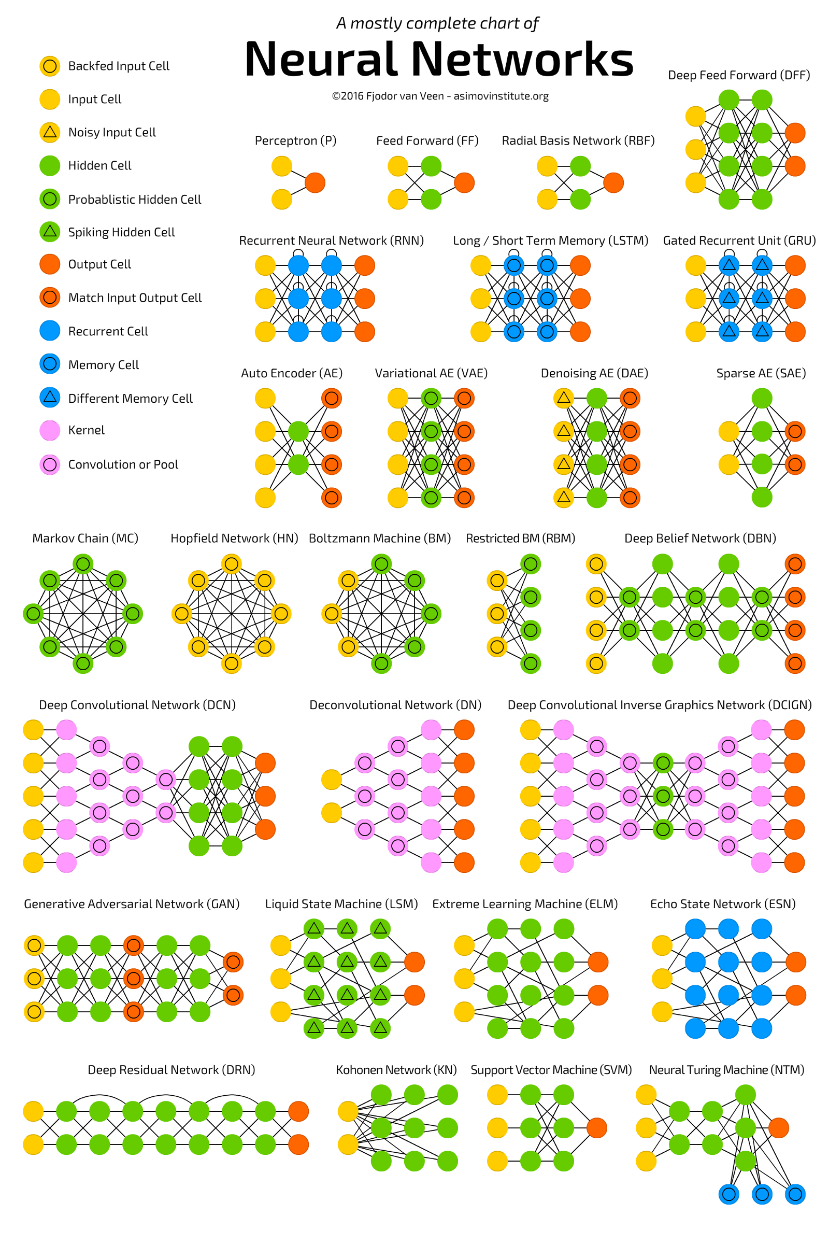

The Neural Network Zoo

**Microsoft Azure Algorithm Flowchart**

Source: <https://docs.microsoft.com/en-us/azure/machine-learning/machine-learning-algorithm-cheat-sheet>

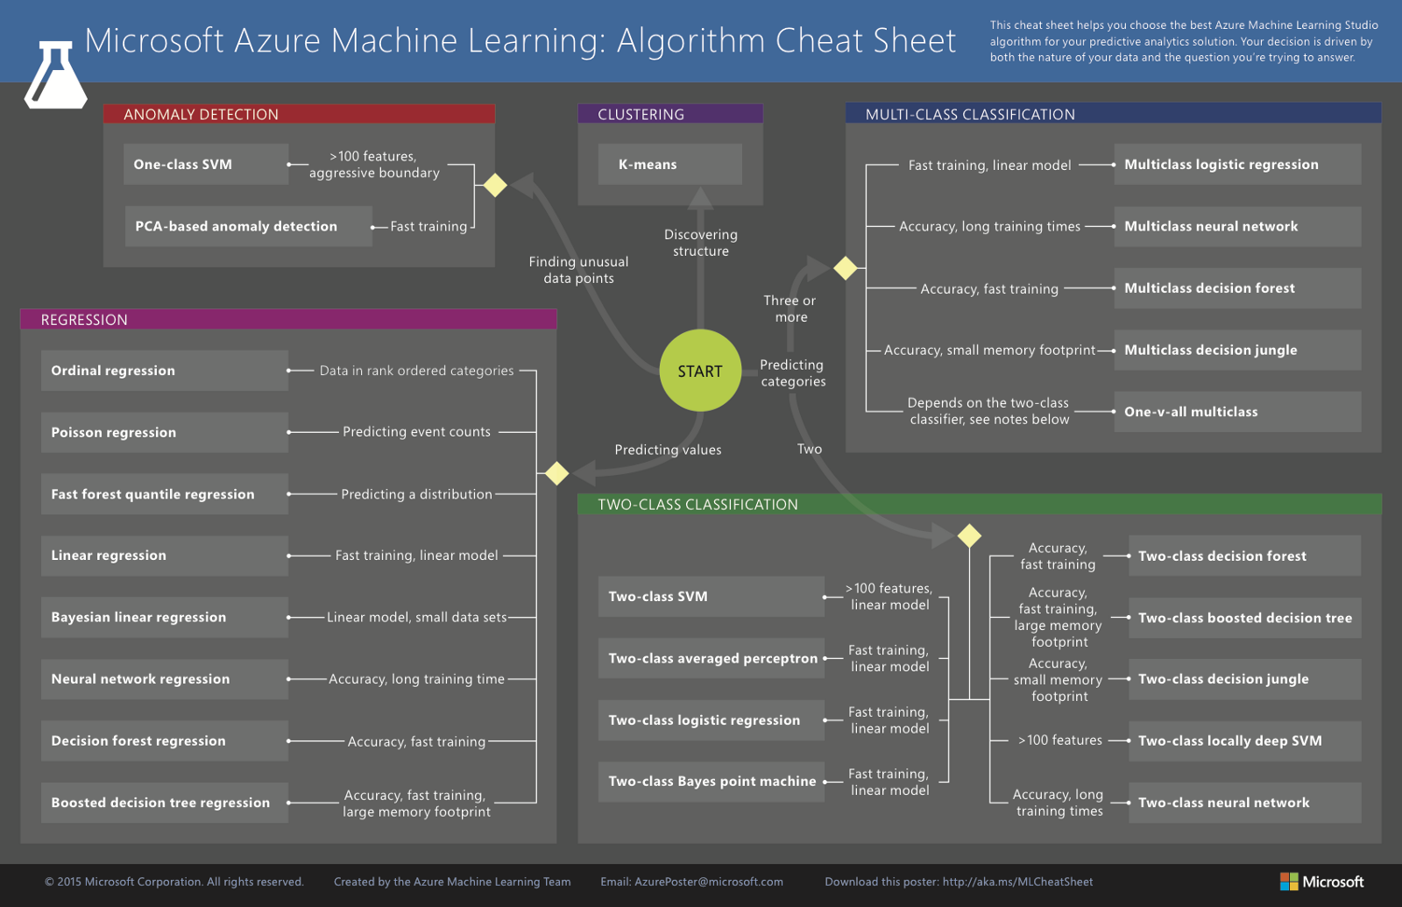

Machine learning algorithm cheat sheet for Microsoft Azure Machine Learning Studio

**SAS Algorithm Flowchart**

Source: <http://blogs.sas.com/content/subconsciousmusings/2017/04/12/machine-learning-algorithm-use/>

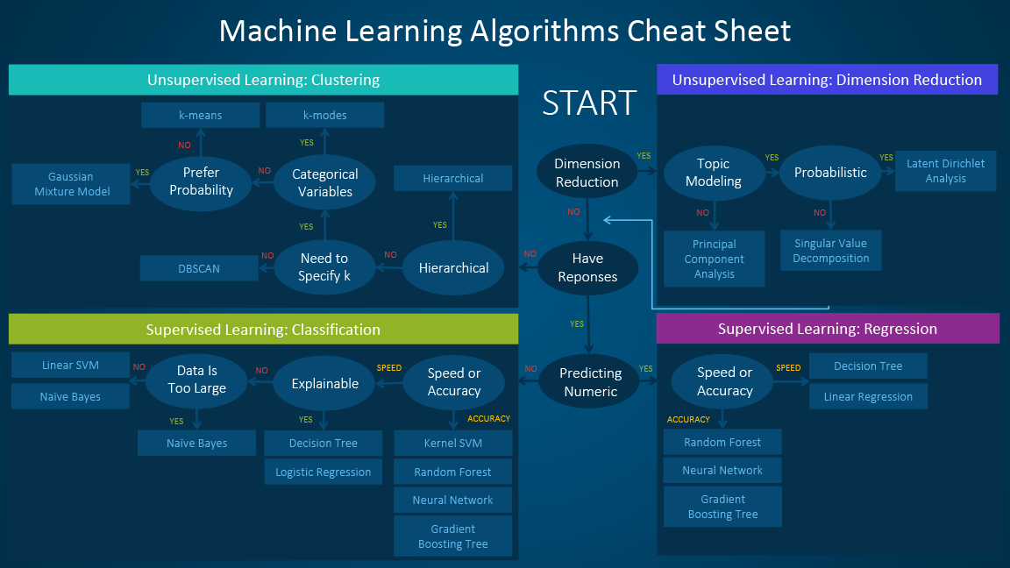

SAS: Which machine learning algorithm should I use?

**Algorithm Summary**

Source: <http://machinelearningmastery.com/a-tour-of-machine-learning-algorithms/>

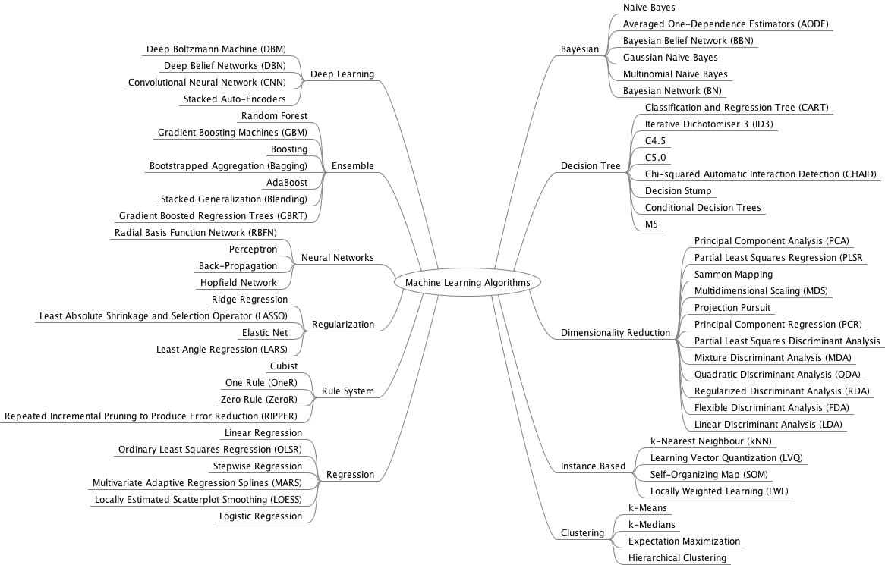

A Tour of Machine Learning Algorithms

Source: [http://thinkbigdata.in/best-known-machine-learning-algorithms-infographic/](http://thinkbigdata.in/best-known-machine-learning-algorithms-infographic/?utm_source=datafloq&utm_medium=ref&utm_campaign=datafloq)

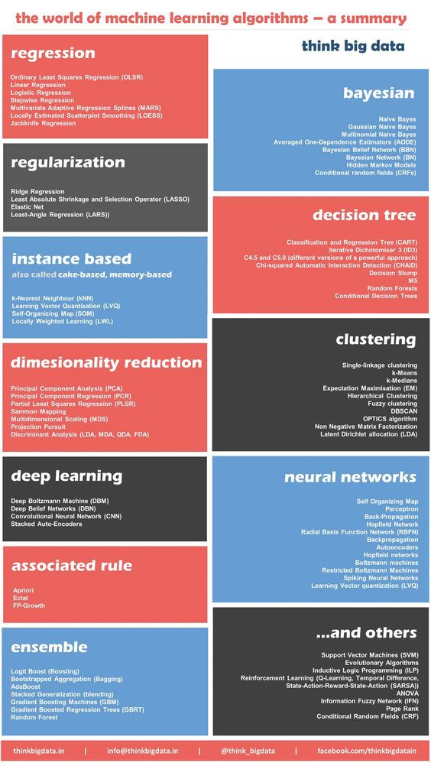

Which are the best known machine learning algorithms?

**Algorithm Pro/Con**

Source: <https://blog.dataiku.com/machine-learning-explained-algorithms-are-your-friend>

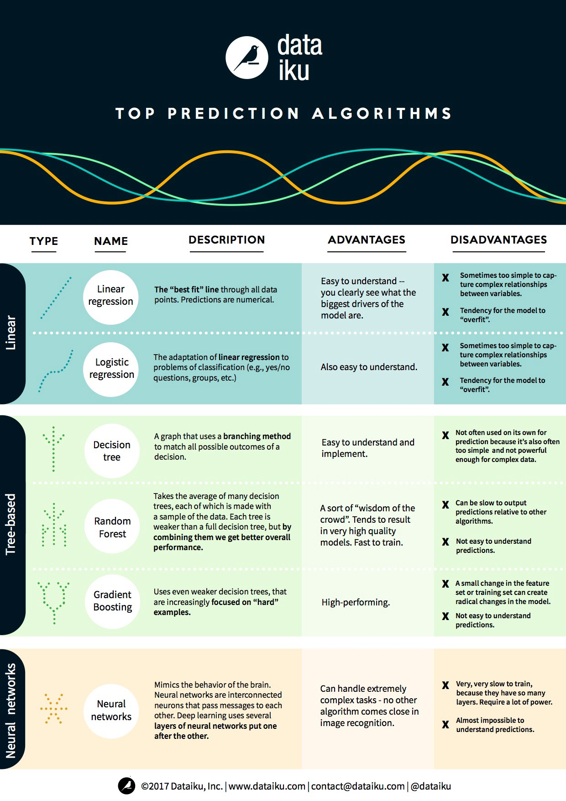

**Python**

Unsurprisingly, there are a lot of online resources available for Python. For this section, I’ve only included the best cheat sheets I’ve come across.

**Algorithms**

Source: <https://www.analyticsvidhya.com/blog/2015/09/full-cheatsheet-machine-learning-algorithms/>

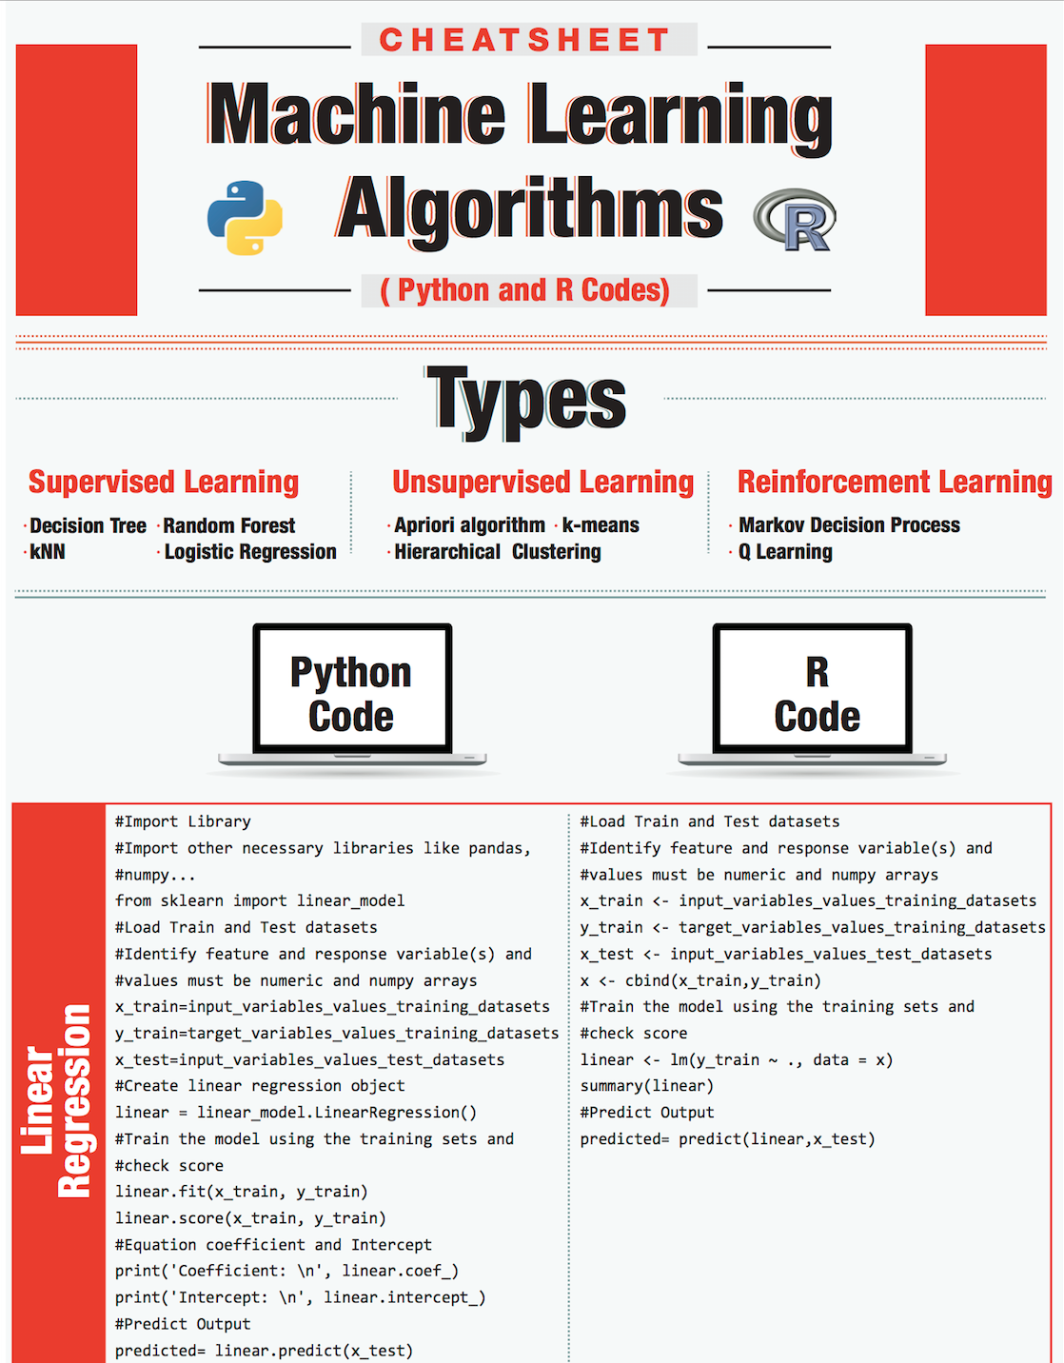

**Python Basics**

Source: <http://datasciencefree.com/python.pdf>

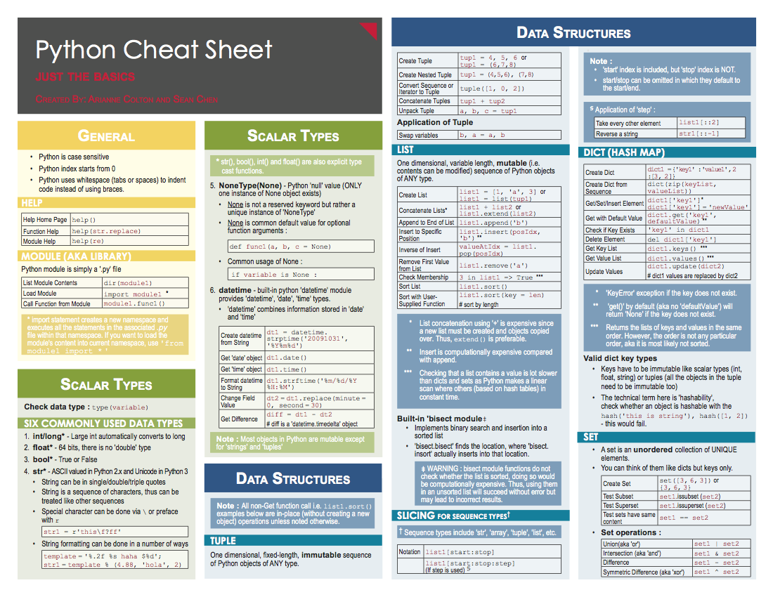

Source: <https://www.datacamp.com/community/tutorials/python-data-science-cheat-sheet-basics#gs.0x1rxEA>

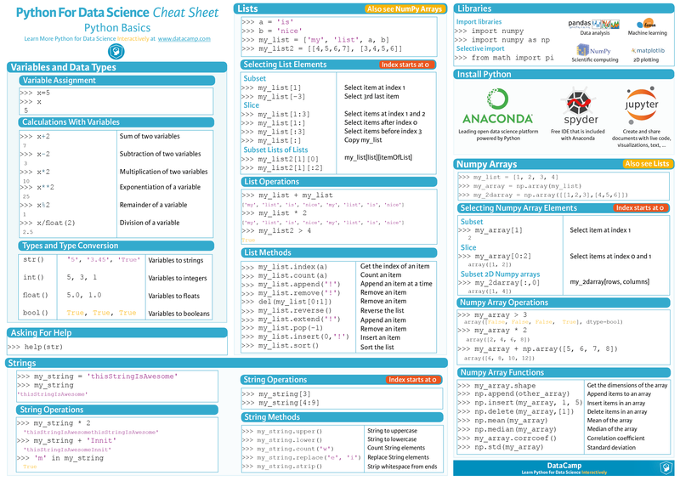

**Numpy**

Source: <https://www.dataquest.io/blog/numpy-cheat-sheet/>

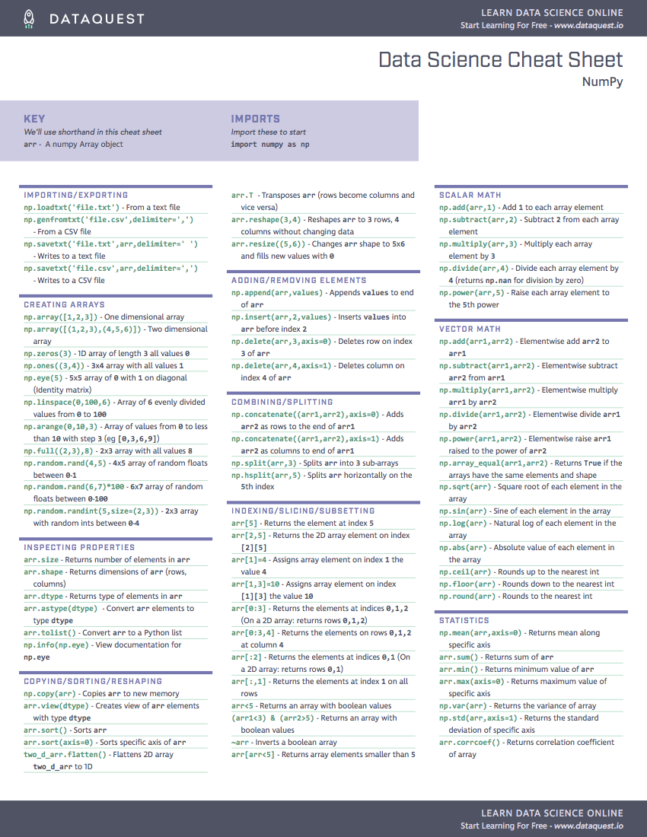

Source: <http://datasciencefree.com/numpy.pdf>

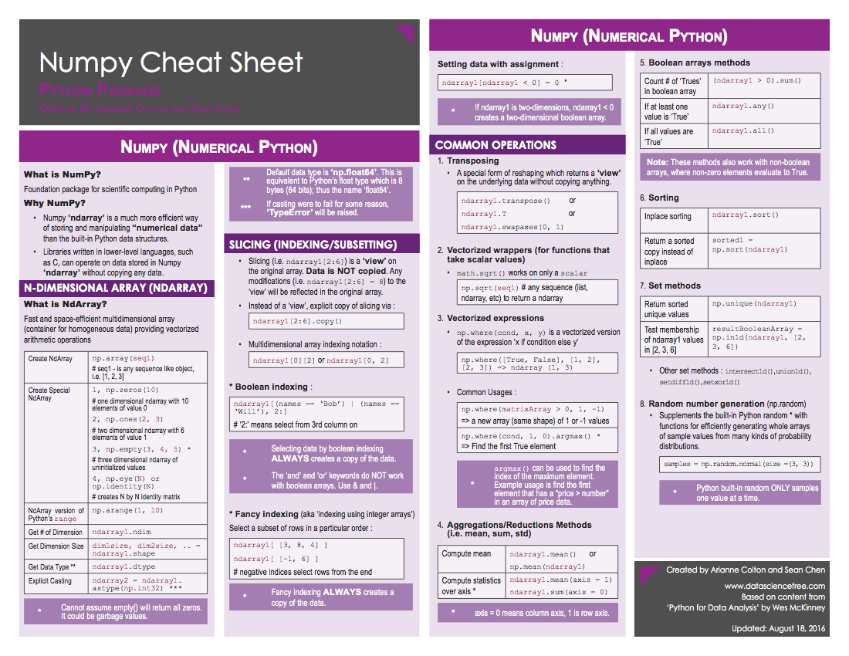

Source: <https://www.datacamp.com/community/blog/python-numpy-cheat-sheet#gs.Nw3V6CE>

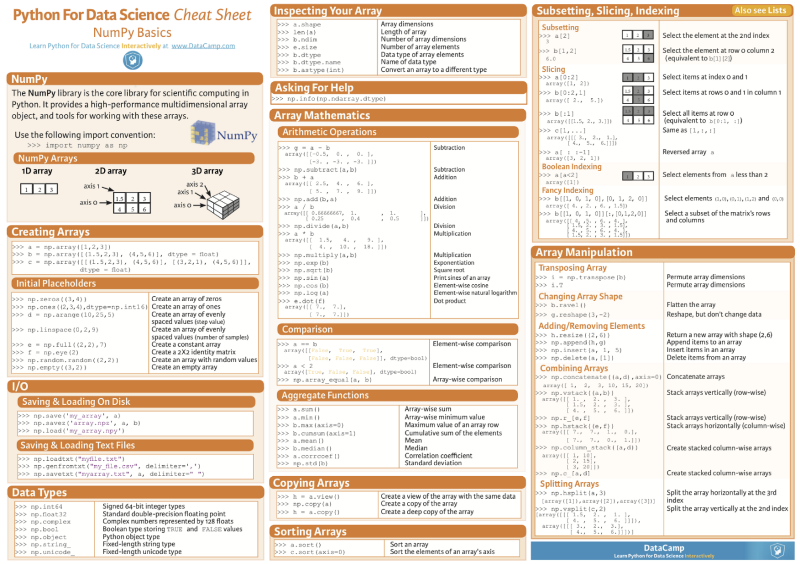

Source: <https://github.com/donnemartin/data-science-ipython-notebooks/blob/master/numpy/numpy.ipynb>

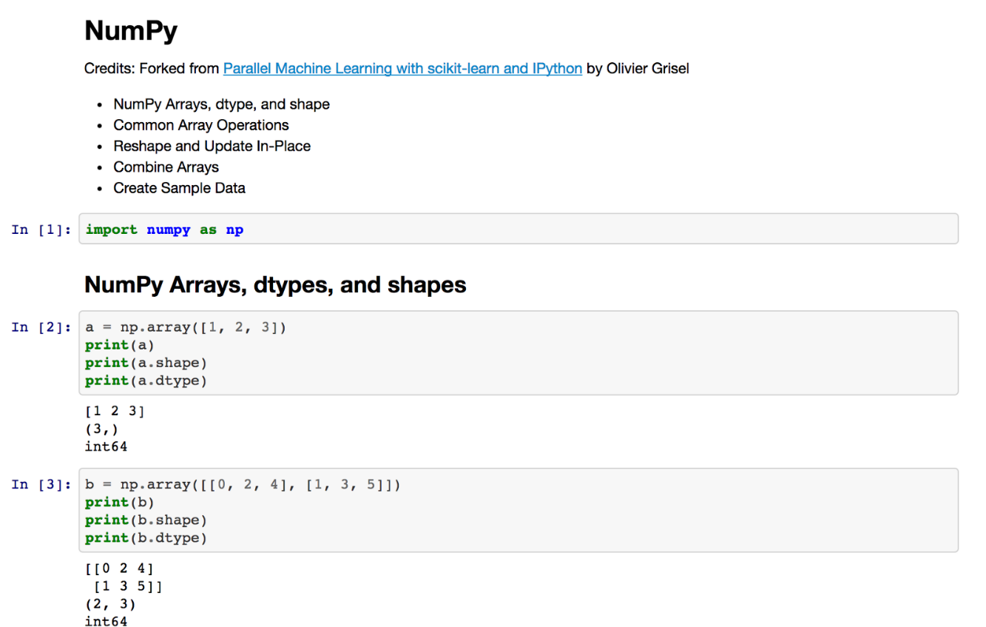

**Pandas**

Source: <http://datasciencefree.com/pandas.pdf>

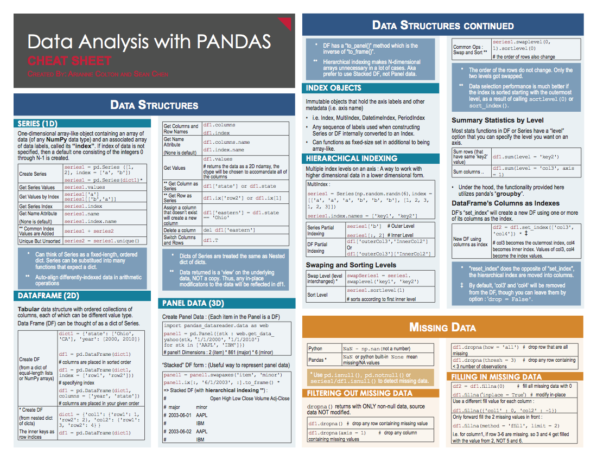

Source: <https://www.datacamp.com/community/blog/python-pandas-cheat-sheet#gs.S4P4T=U>

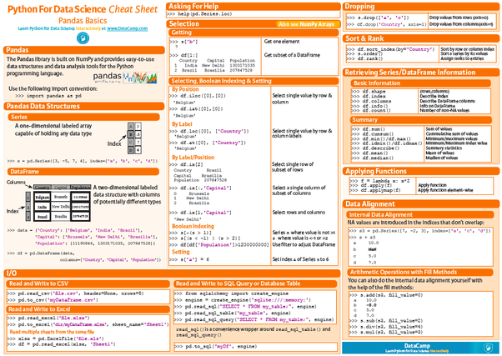

Source: <https://github.com/donnemartin/data-science-ipython-notebooks/blob/master/pandas/pandas.ipynb>

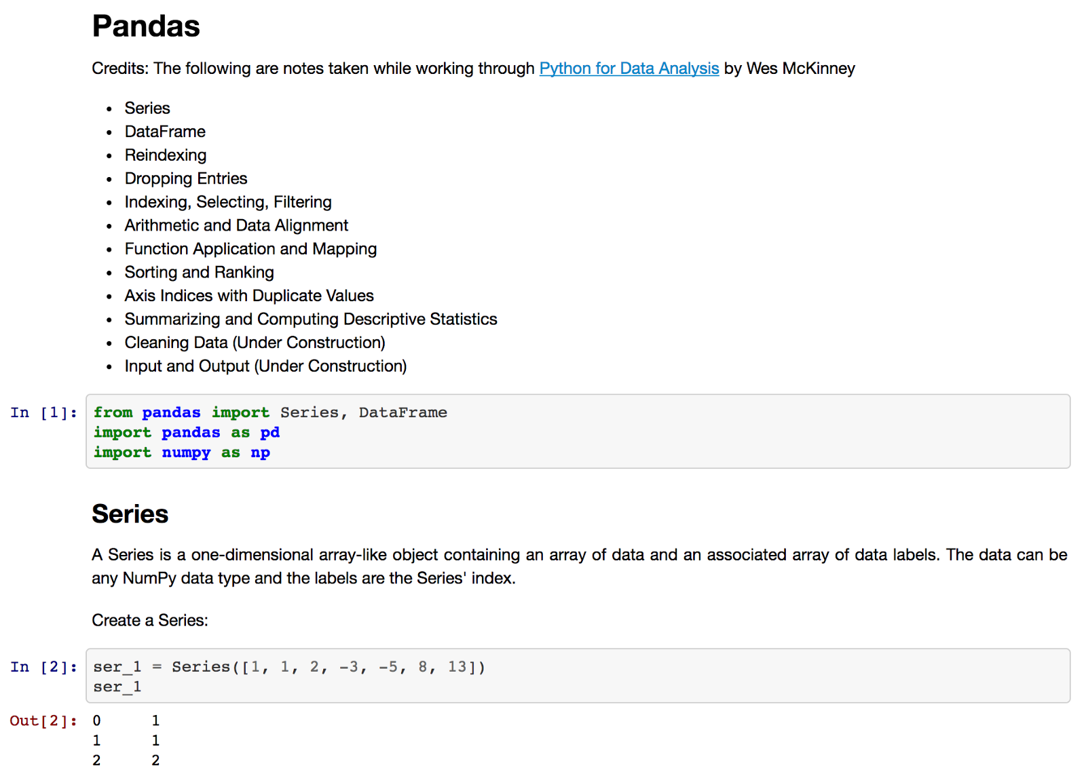

**Matplotlib**

Source: <https://www.datacamp.com/community/blog/python-matplotlib-cheat-sheet>

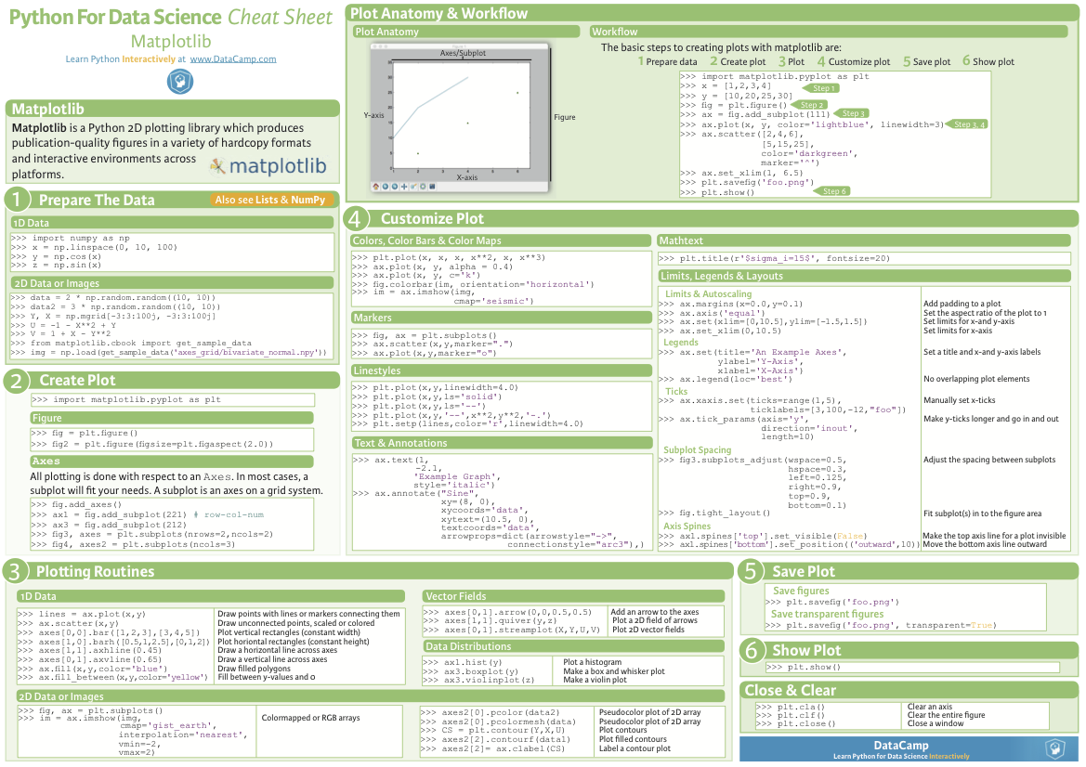

Source: <https://github.com/donnemartin/data-science-ipython-notebooks/blob/master/matplotlib/matplotlib.ipynb>

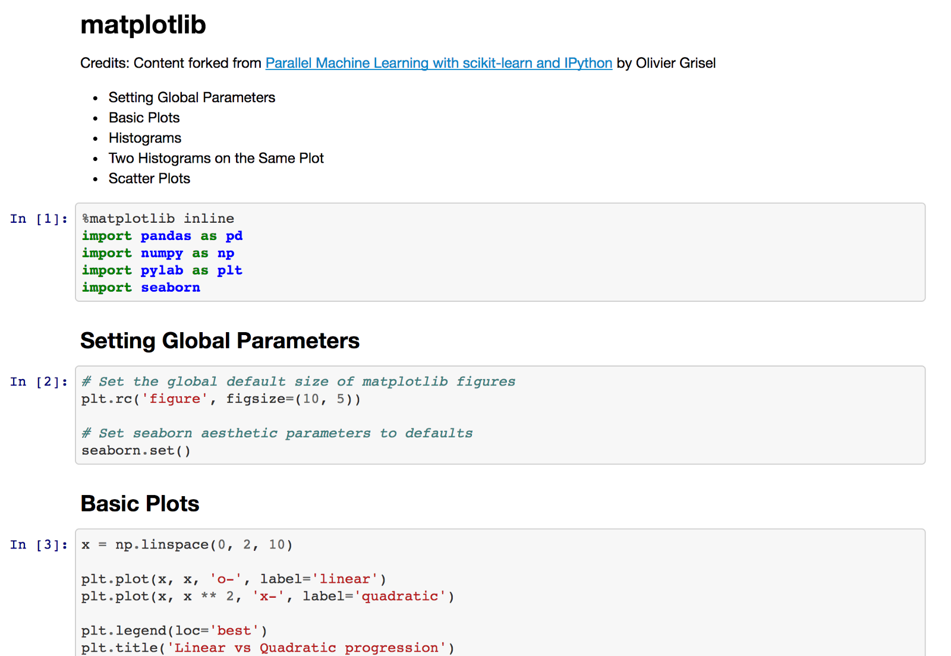

**Scikit Learn**

Source: <https://www.datacamp.com/community/blog/scikit-learn-cheat-sheet#gs.fZ2A1Jk>

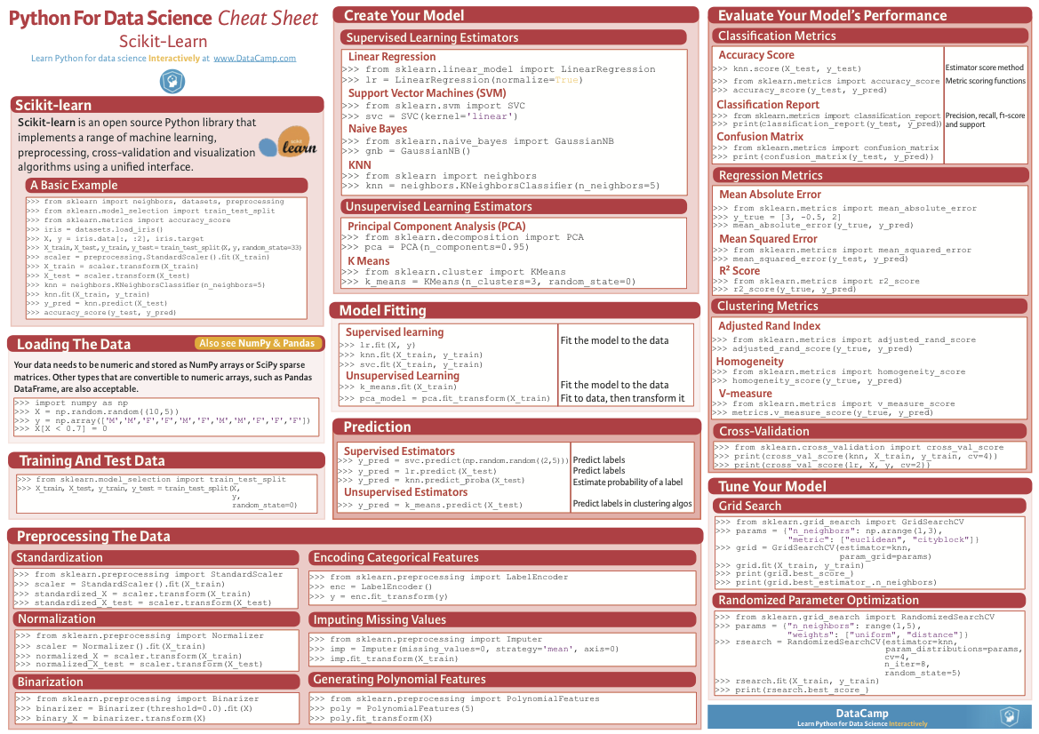

Source: <http://peekaboo-vision.blogspot.de/2013/01/machine-learning-cheat-sheet-for-scikit.html>

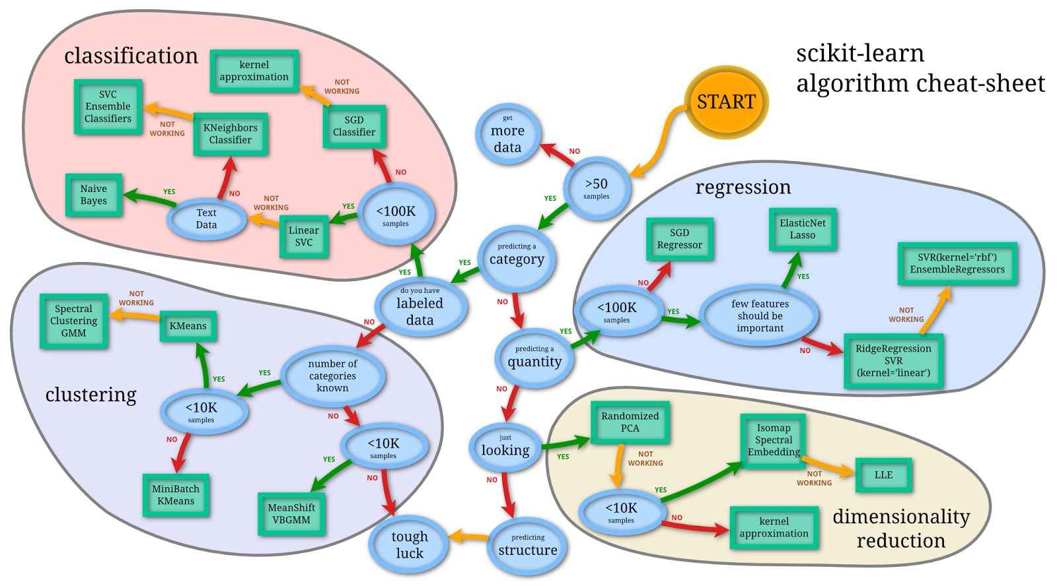

Source: <https://github.com/rcompton/ml_cheat_sheet/blob/master/supervised_learning.ipynb>

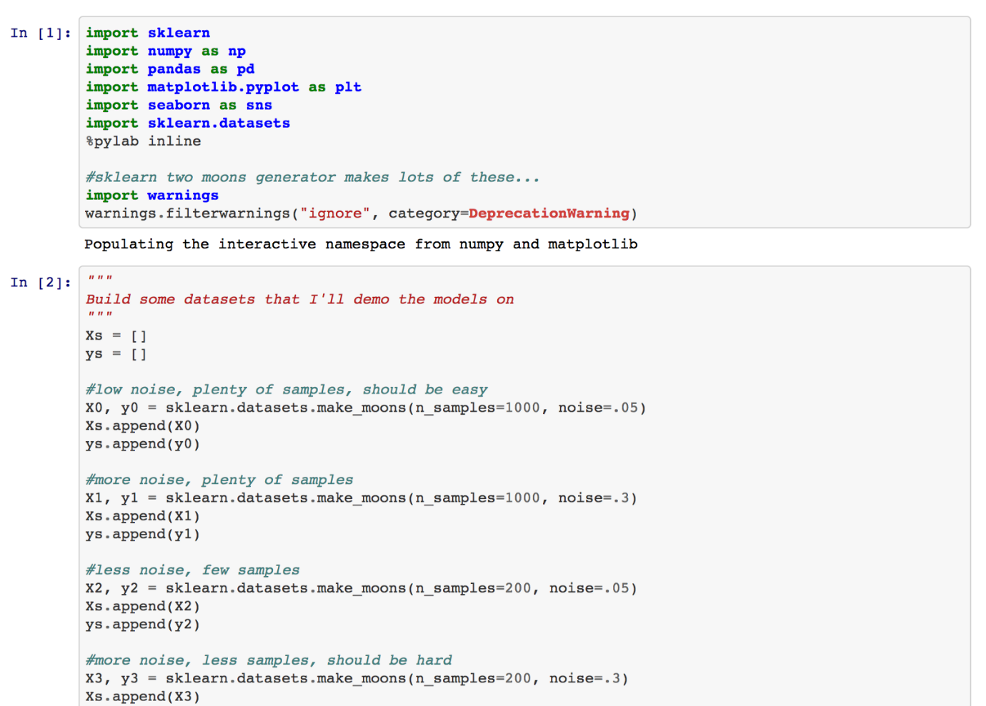

**Tensorflow**

Source: <https://github.com/aymericdamien/TensorFlow-Examples/blob/master/notebooks/1_Introduction/basic_operations.ipynb>

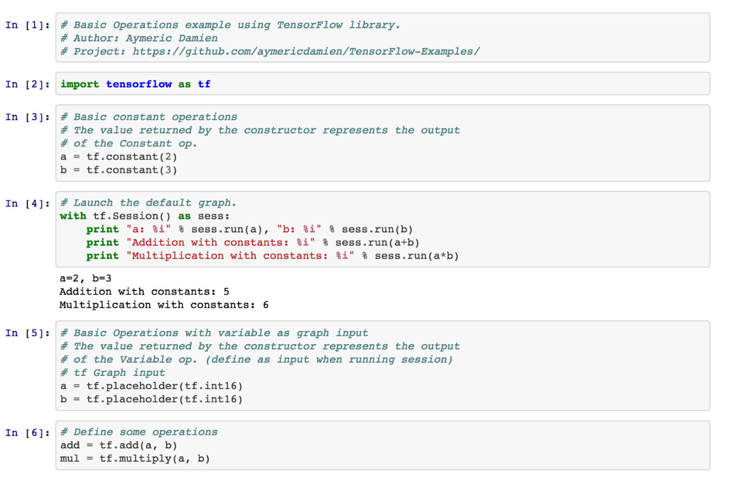

**Pytorch**

Source: <https://github.com/bfortuner/pytorch-cheatsheet>

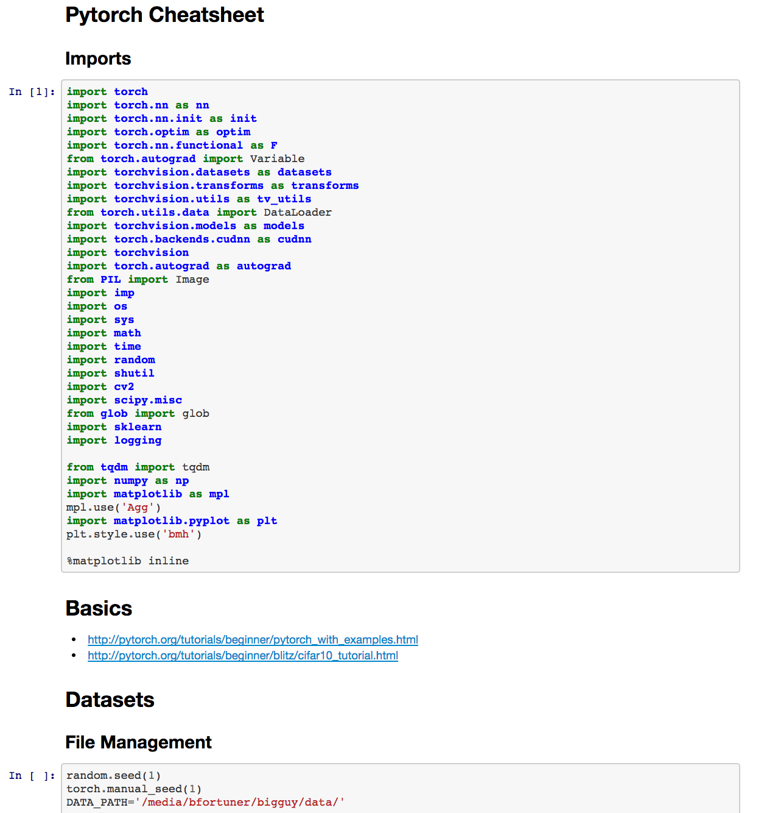

**Math**

If you really want to understand Machine Learning, you need a solid understanding of Statistics (especially Probability), Linear Algebra, and some Calculus. I minored in Math during undergrad, but I definitely needed a refresher. These cheat sheets provide most of what you need to understand the Math behind the most common Machine Learning algorithms.

**Probability**

Source: <http://www.wzchen.com/s/probability_cheatsheet.pdf>

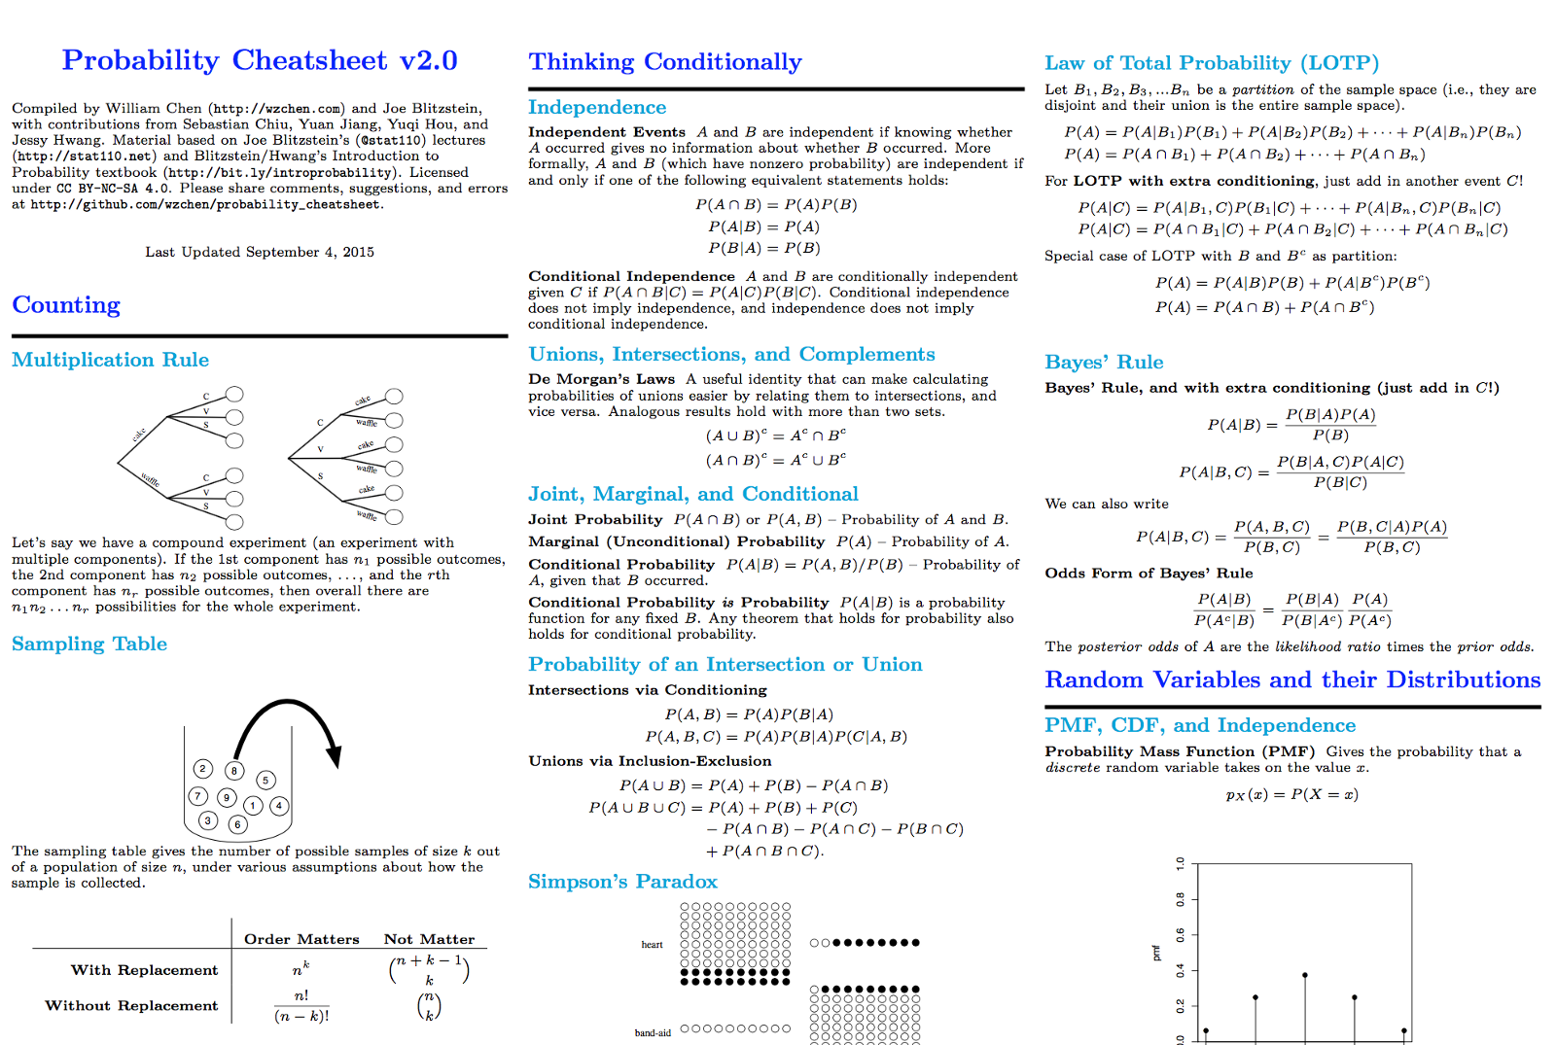

Probability Cheatsheet v2.0

**Linear Algebra**

Source: <https://minireference.com/static/tutorials/linear_algebra_in_4_pages.pdf>

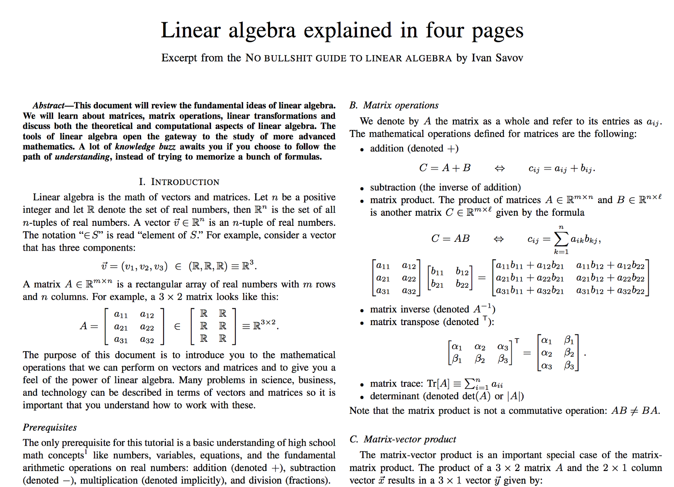

Linear algebra explained in four pages

**Statistics**

Source: <http://web.mit.edu/~csvoss/Public/usabo/stats_handout.pdf>

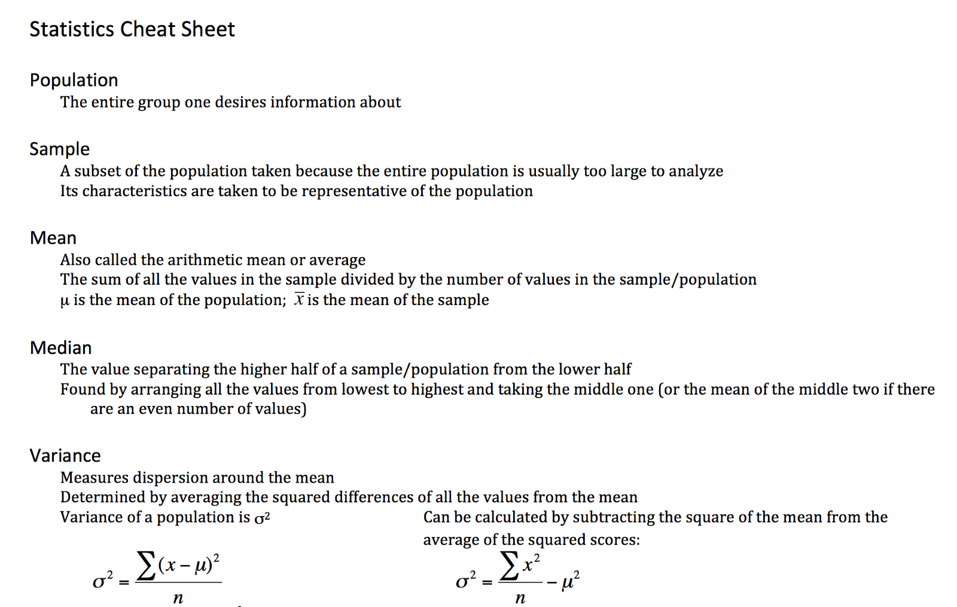

Statistics Cheat Sheet

**Calculus**

Source: <http://tutorial.math.lamar.edu/getfile.aspx?file=B,41,N>

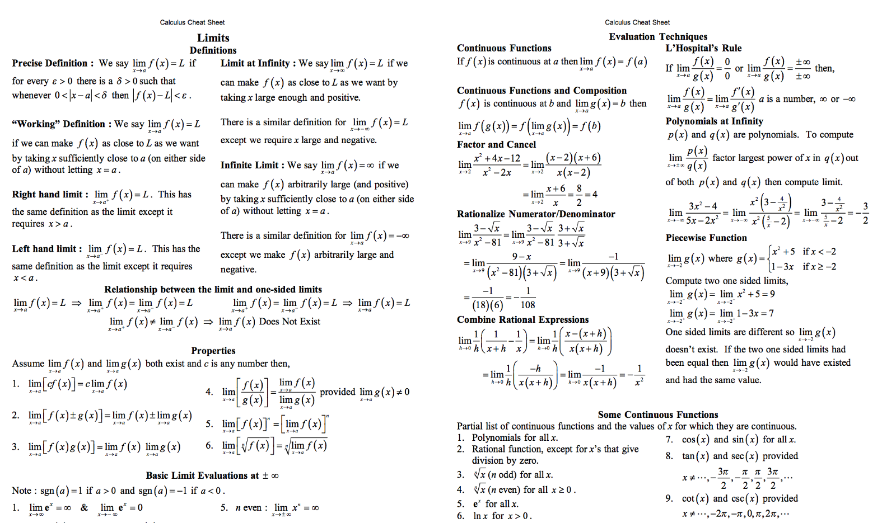

Calculus Cheat Sheet